Deepalakshmi Natarajan
Application Development Senior Analyst

A self-motivated woman with keen interest to glow on advanced technologies seeks employment in a challenging environment which gives satisfaction of adding value to the organization while concurrently upgrading personal skills and knowledge.
Dedicated professional with 7+years of experience in system integration development & testing, project management, quality control and quality assurance.

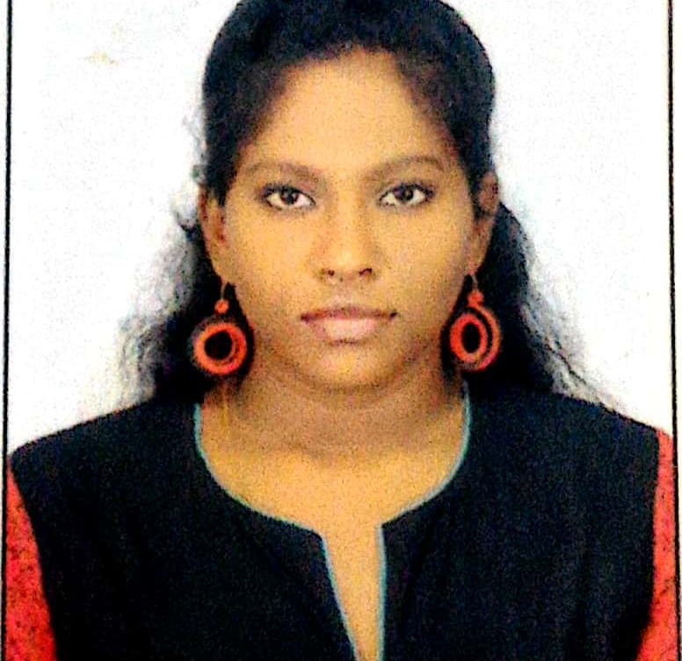

PROFILE SUMMARY

Mobile: +91 7401286335
Email: deepnats148@gmail.com
Current Location: Bengaluru

- Telecommunication
- Life Science
- Water Treatment

ADDRESS

No:2, Subramanya Nilayam, 1st cross road, sarvagna nagara, scout camp road, 6th division, dodballapur, Bengaluru 561203.
Pincode: 600045
DOMAIN

- Agile Project Management
- Project Planning
- Resource Planning
- Requirement/Scope Management
- Stakeholder Management
- Test Planning & Reporting
- Risk Management
- Quality Control
- Factory Talk Pharma Suite.
- Azure Cloud

- Good experience in working with stakeholders both onshore and offshore.
- Strong experience in requirement gathering, scope analysis and explaining the scope with team members.
- Responsible for project strategy planning, allocation of resources, requirement gathering and budget proposals.
- 7+ years of experience in technical writing, problem solving, budget management and adaptable to different domains & technologies.
- Lead and manage quality focused UAT test execution events, in alignment with UAT entry/exit criteria, timeline, budgetary and resourcing constraints of an entire project across various platforms.

- AWS Cloud
- System Integration
- Agile Methodology
- Python
- Factory Talk View Machine Edition HMI
- Factory Talk View Site Edition SCADA
- RS Logix 5000 (Allen Bradley PLC)
- Wonderware SCADA
- HP ALM
- Helix ALM

SKILLS
SKILLS

* Azure/AWS Cloud computing
* ANSI SQL- SQL Server & Toad
* FTPS/FTPC
* Factory Talk View Machine
Edition HMI
* E-designer HMI
* Factory Talk View Site
Edition SCADA
* RSview32 SCADA
* RS Logix 5000 (Allen Bradley PLC)
* RS Teststand
* Wonderware SCADA

British Telecom Everything Everywhere (June 2019 – Till date)
(Project Management, Quality Assurance, Test Planning, Delivery Management)



ROLES & RESPONSIBILITIES – Accenture India Pvt. Ltd. (May 2018 – Till date)
Pfizer (May 2018 – June 2019)
(Cloud computing, Project planning, Time Management & Project Life Cycle Planning)



- Good experience in Devops and Agile methodologies.
- Good knowledge on Agile project management and have received recognition for the same by Accenture.
- Responsible to understand the scope/requirements and develop the test plan and test scheduling activities.
- Experienced working in project management tools like HP ALM.
- Responsible to discuss with stakeholder and get revised funding’s if efforts cross the specified estimate/budget.
- Work closely with stakeholders to meet end to end project needs and ensure testing team responsibilities are being met.
- Responsible for the quality of deliverables and act as a point of contact for all communications and escalations.
- Responsible to understand the scope and requirements of the project/PLT (Pre-launch testing) and communicate to the testers to drive them for successful project delivery.
- Responsible to understand software development life cycle (SDLC) and perform test management activities accordingly.
- Responsible for coordination, communication, training, execution and management of the project Testing Defect Resolution Process.
- Review and approve documents like high/low level test scenarios/test cases prepared by testers on basis of quality, scope coverage, standards and compliance prior delivering it to the stakeholders.
- Responsible for leading the Go-live event/activity from UAT end.
- Analyse the challenges faced for an ‘Go’ decision and coordinate with the relevant teams for a successful ‘Go’ decision.
- 7+ years of experience working in production environment.

- Experienced in delivering scalable & reliable Manufacturing Execution System’s critical applications on time to meet the ever-changing demands of customers.
- Experienced in explaining the technical query and challenges the development team will face with a particular process/scenario to the stakeholders and derive a solution to handle it effectively.
- Collaborated with end users, product support team and other required technical teams to find out the root cause of an issue and explain it to the stakeholder in an easy understandable way.
- Strong experience in requirement gathering and query management and project life cycle planning activities in life science domain.
- Understand the scope and prepare the budget and discuss with the vendors on the pricing and operational details.
- SME in industrial automation process and trained the team members with real-time industrial operations, effects of production impacts on business, product manual analysis to fit into budget, importance of industrial security & safety and conducted brainstorming sessions to fill knowledge gaps.
- Experienced in continuous delivery and continuous integration methodology.
- Part of global MES team for resolving live production issues that impacts direct production.
- Experienced working in application lifecycle management tool like HP ALM
- Strong presentation skills with the ability to present technical proposals and designs at ease.
- Interested in continuous learning and upgrading with new skills and latest technologies.
- Hands-on experience with AWS Virtual servers and network components.
- Proven knowledge of cloud concepts like availability zones, regions, virtual private networking and network security group.
- Good knowledge on Azure Key Pairs, Virtual LAN, Security Access and other cloud computing basic concepts.

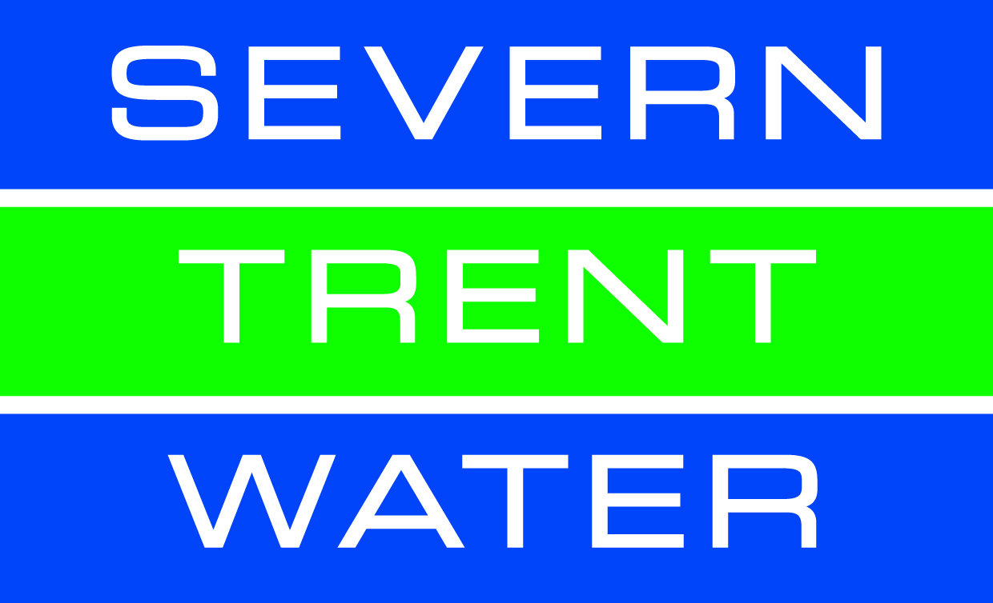
Severn Trent Waters (STW) (Oct 2013- May 2018)
(Technical Writing, Query Management, Requirement Gathering, HMI, SCADA & PLC)

- Responsible for raising technical query and discussing with clients and troubleshoot any challenges faced.
- Prepared the project schedule & updated the activities in schedule chart periodically.
- Preparing Input/Output list based on the quotation, single line diagram, block cable diagram, piping & instrumentation diagram and user requirement specifications.
- Conduct technical meetings with client and understand the requirement and necessary software version required for the project.
- Maintain good rapport with client and conduct periodic project meetings to be aware of any current risk faced in site and discuss on the mitigation followed.
- Handled multiple projects independently in the same period, responsible for coordination, timely development, production functioning and smooth completion of the project during site testing.
- Good experience in technical writing and created technical documents like functional design specification, integrated factory acceptance test, costumer factory acceptance test and detailed design specification.
- 4+ years of experience as quality control lead. Responsible to maintained quality of all the documents & software for entire jobs/projects received by the company.
- Develop and test HMI graphics, which includes process control, overview displays, cause & effects based on the P&ID's (Piping & Instrumentation Diagram).
- Developing dynamic shapes, faceplates & Testing it. Developing SCADA mimics and testing it with PLC code and HMI via communication modules like Kepware.
- Analysing/verifying the panel engineering documents (general arrangement drawing, ICA panel & other wiring drawings) for the software development.
- Analyse BOM, drive schedule, valve schedule, instrument schedule & telemetry schedule to design the process.
- Experience in developing I/O schedule and functional documentation of Industrial Protocols like Modbus, Ethernet, PROFIBUS, PROFINET and DeviceNet etc.

ROLES & RESPONSIBILITIES – CEMA Automations India Pvt. Ltd. (Oct 2013 – May 2018)
B.E. Electronics and Instrumentation Engineering (2009-2013)
Sri Sairam Engineering College; CGPA: 7.88 (CGPA)

Fathers’ Name: Natarajan S
Gender: Female
Date of Birth: 05.04.1992
Nationality: Indian
Languages Known: English, Hindi and Tamil.
Passport No: L2304471

Full stack automation engineer in R AI & Python AI certified by Accenture Automation university
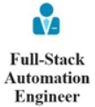
https://www.youracclaim.com/badges/cc0b9ac6-dd3d-4b6d-9d2d-aff45446788c/public_url

CERTIFICATIONS:
EDUCTIONAL QUALIFICATION:

